Boggy Sands beach access paths locked and gated
November 3, 2016

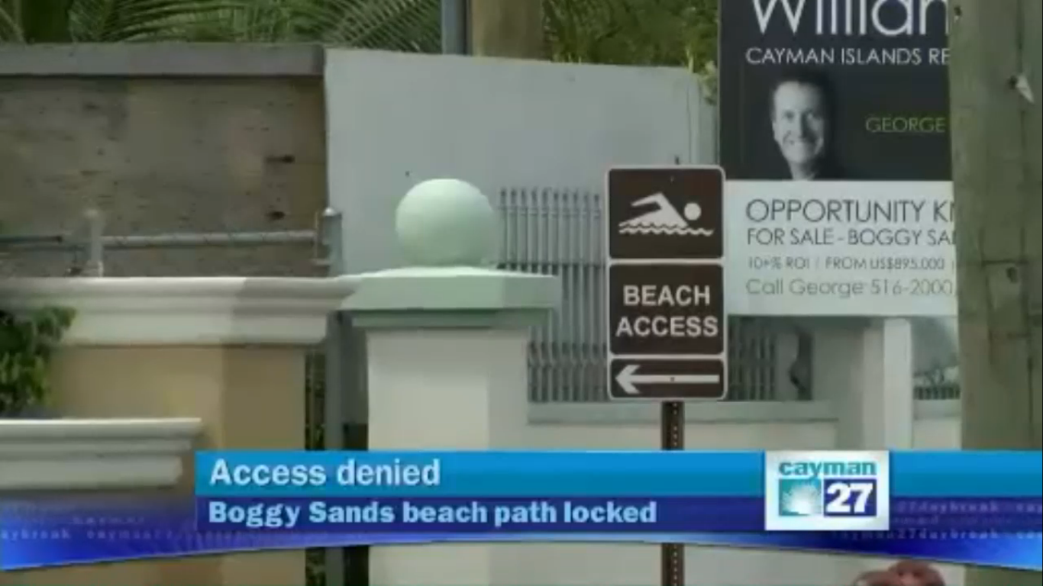
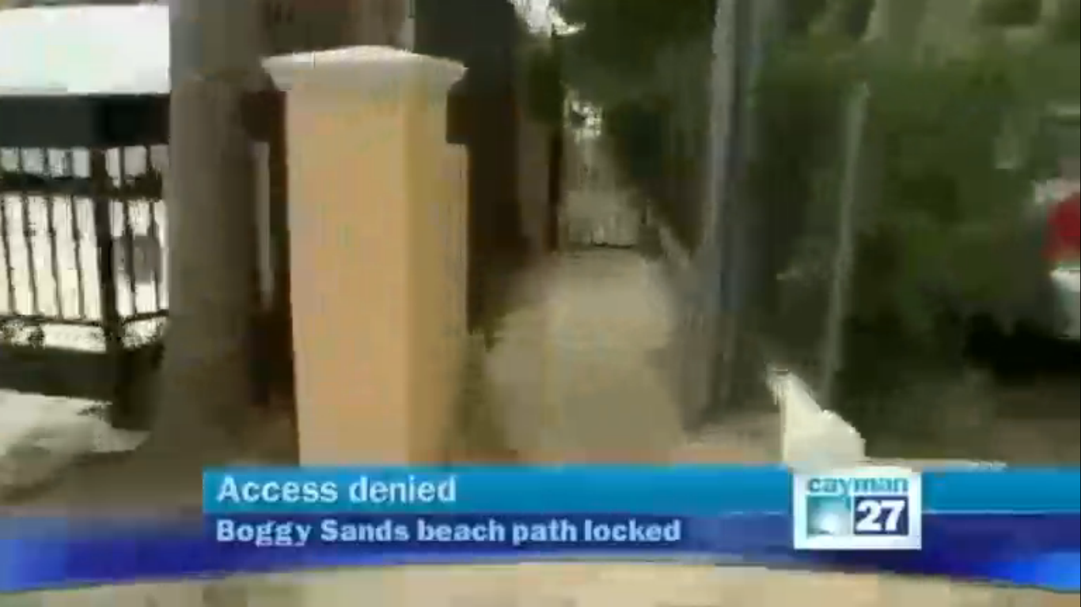
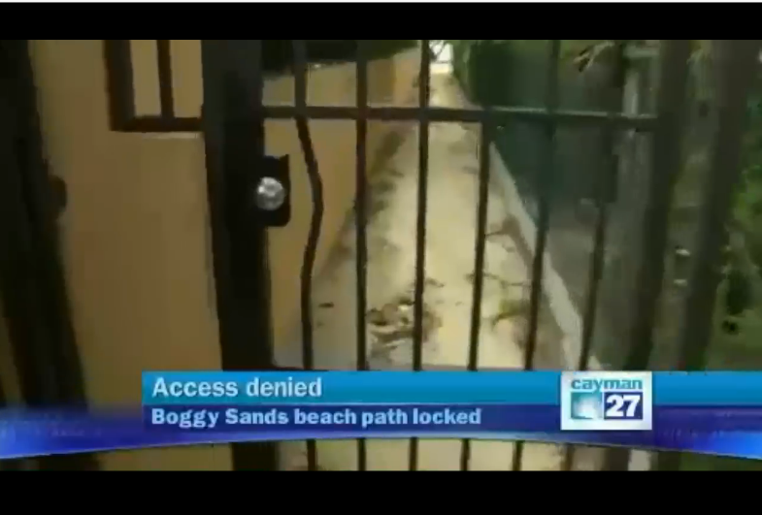
Beach access: denied.
Those seeking sand and sun at Boggy Sands Beach are in for a long walk down this beach access path originating at West Bay Road. But after walking 486 feet, almost a tenth of a mile, would-be beach goers are blocked with a locked gate.
“We used to have three public accesses, people closed it off with private gates, it’s just a problem for everyone,” said Morne Botes, the developer behind the Boggy Sands Club condo project.
Cayman 27’s cameras spotted only one marked and unobstructed beach access along Boggy Sands Road, and even it was sending mixed messages. In concrete, the words ‘private right of way’ are etched in block letters on a concrete slab.
A couple adventurous tourists from down under found it too, but told Cayman 27 it wasn’t easy.
“It would be really nice to access the beach really easily,” said tourist Elisha Pritchard.
“There were no marked areas to get off the beach, but we tried our luck and found ourselves a pathway, so we were quite lucky,” said her traveling companion Elana Clarke.
Cayman 27 identified three other potential beach access pathways, all of them were locked and gated.
While finding a path to the beach was a challenge, getting in touch with officials at Planning has proved next to impossible.
Several days worth of calls and emails to Deputy Director Ron Sanderson inquiring about these and other beach access points have gone ignored.

Do you know of a beach access path that is blocked, unmarked, overgrown, obstructed, sketchy, or otherwise difficult to navigate?
Call Cayman 27’s Joe Avary on 324-2141

