MLA motion aims to protect beach access routes for Caymanians
OcTOBER 14, 2016
http://cayman27.ky/2016/10/mla-motion-aims-to-protect-beach-access-routes-for-caymanians/
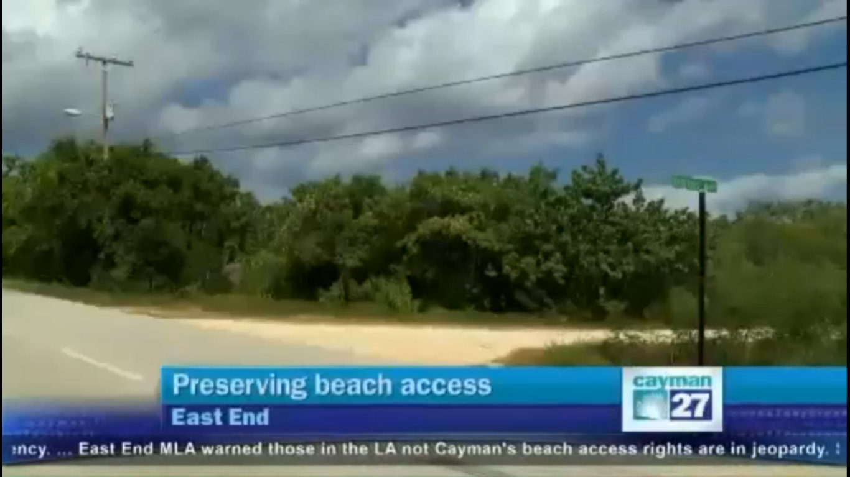
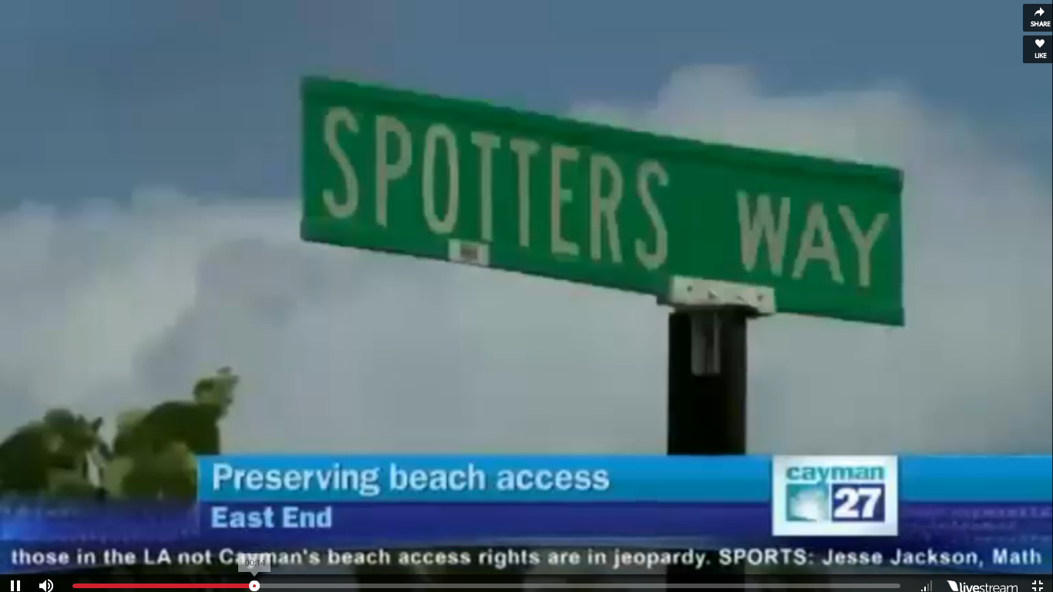
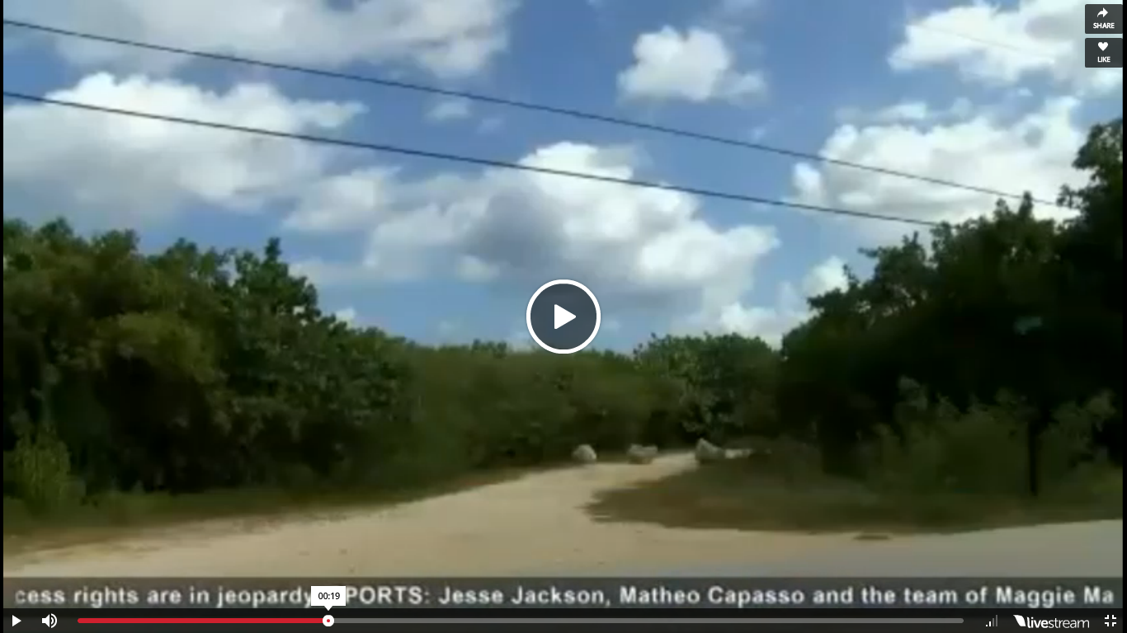
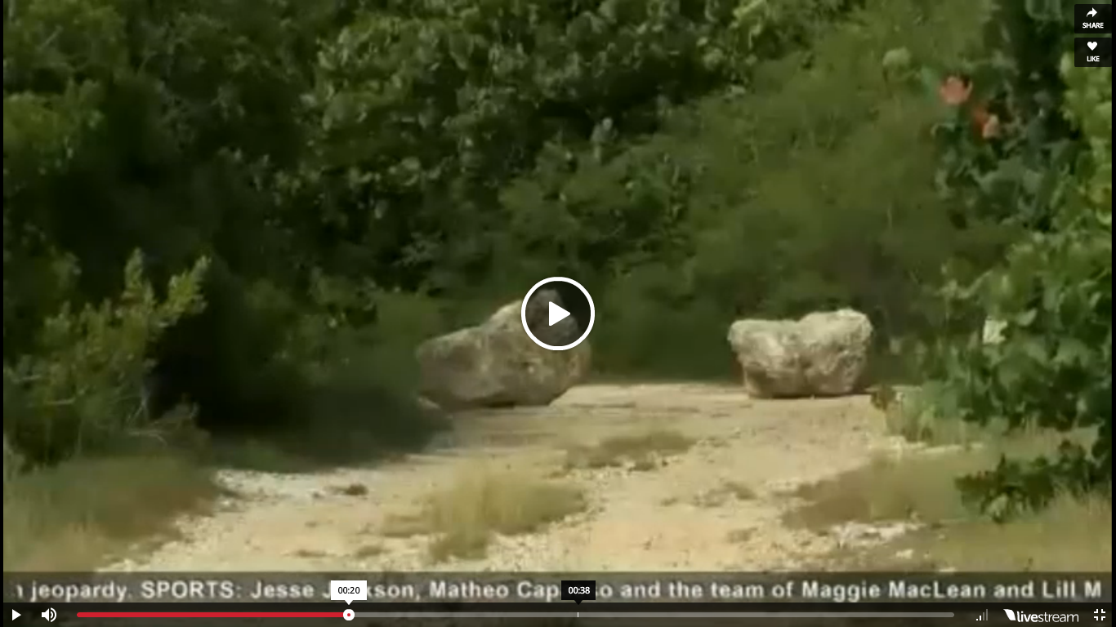


East End MLA Arden McLean has a warning – Caymanians’ ‘indefeasible’ rights to beach access, held for more than a century, are in jeopardy.
Mr. McLean pointed to a path at Spotter’s Way in East End as a perfect example. Large boulders have been placed to block vehicle access to the long footpath from the Queen’s Highway to the beach.
Mr. McLean told Cayman 27 under the 1882 prescription law, which was transferred to our law books in 1964, paths to the beach that have been utilised uninterrupted for 20 years are protected absolutely.
He said giving an inch to developers on just one of these heritage paths is a slippery slope he believes will spell an end to beach access rights.
“You have the same prescriptive right between the high water mark and the low water mark, but if you remove any one of those, the other ones, then we run the risk that the others come into question as well, and we could be walking along the beach and they say no you can’t walk any further, and that is a dangerous position to be in,” said Mr. McLean.
Mr. McLean’s private member’s motion, tabled in the LA this week, seeks to amend the law to enforce access rights. Debate will continue on the motion next week.

